ECE 2305
Introduction to C Programming

Programming Project 08

Gaussian Elimination

Program Features: Two dimensional arrays, Dynamic Memory Allocation.

Create a C++ program that will find the solution to a set of linearly independent equations using Gaussian elimination. Write the program in general terms so that it can be applied to any set of equations. The set of $n$ equations have the form

$a_{0,0} x_{0}$ | + | $a_{0,1} x_{1}$ | + | $a_{0,2} x_{2}$ | + | $$⋯$$ | + | $a_{0,n-1}{ x}_{n-1}$ | = | $b_{0}$
$a_{1,0} x_{0}$ | + | $a_{1,1} x_{1}$ | + | $a_{1,2} x_{2}$ | + | $$⋯$$ | + | $a_{1,n-1}{ x}_{n-1}$ | = | $b_{1}$
$a_{2,0} x_{0}$ | + | $a_{2,1} x_{1}$ | + | $a_{2,2} x_{2}$ | + | $$⋯$$ | + | $a_{2,n-1}{ x}_{n-1}$ | = | $b_{2}$
 |  |  |  |  |  | $$⋮$$
$a_{n-1,0} x_{0}$ | + | $a_{n-1,1} x_{1}$ | + | $a_{n-1,2} x_{2}$ | + | $$⋯$$ | + | $a_{n-1,n-1} x_{n-1}$ | = | $b_{n-1}$

where $a_{ij}$ and $b_{k}$ are coefficients that are input by the user and $x_{k}$ are unknowns for which the application will solve.

If the set of cannot be solved (because of a division by zero error), the application should display a warning message.

A general set of linearly independent equations may be written in the form

$$\left[\begin{matrix}a_{0,0}^{} & a_{0,1}^{} & a_{0,2}^{} & ⋯ & a_{0,n-1}^{} \\ a_{1,0}^{} & a_{1,1}^{} & a_{1,2}^{} & ⋯ & a_{1,n-1}^{} \\ a_{2,0}^{} & a_{2,1}^{} & a_{2,2}^{} & ⋯ & a_{2,n-1}^{} \\ ⋮ & ⋮ & ⋮ & ⋱ & ⋮ \\ a_{n-1,0}^{} & a_{n-1,1}^{} & a_{n-1,2}^{} & ⋯ & a_{n-1,n-1}^{}\end{matrix}\right]\left[\begin{matrix} x_{0}^{} \\ x_{1}^{} \\ x_{2}^{} \\ ⋮ \\ x_{n-1}^{}\end{matrix}\right]=\left[\begin{matrix}b_{0}^{} \\ b_{1}^{} \\ b_{2}^{} \\ ⋮ \\ b_{n-1}^{}\end{matrix}\right]$$

An algorithm for Gaussian elimination (written in pseudo-code) is as follows:

For rows $k=0$ to $n-2$, assuming $a_{k,k}^{}≠0$
For rows $i=k+1$ to $n-1$, define the row multipliers

$$m=\frac{a_{i,k}^{}}{a_{k,k}^{}}$$

For columns $j=k$ to $n-1$

$$a_{i,j}^{}=a_{i,j}^{}-ma_{k,j}^{}$$

Next $j$
$$b_{i}^{}=b_{i}^{}-mb_{k}^{}$$
Next $i$
Next $k$

After this procedure the matrix equation takes the form

$$\left[\begin{matrix}a_{0,0}^{} & a_{0,1}^{} & a_{0,2}^{} & ⋯ & a_{0,n-1}^{} \\ 0 & a_{1,1}^{} & a_{1,2}^{} & ⋯ & a_{1,n-1}^{} \\ 0 & 0 & a_{2,2}^{} & ⋯ & a_{2,n-1}^{} \\ ⋮ & ⋮ & ⋮ & ⋱ & ⋮ \\ 0 & 0 & 0 & ⋯ & a_{n-1,n-1}^{}\end{matrix}\right]\left[\begin{matrix} x_{0}^{} \\ x_{1}^{} \\ x_{2}^{} \\ ⋮ \\ x_{n-1}^{}\end{matrix}\right]=\left[\begin{matrix}b_{0}^{} \\ b_{1}^{} \\ b_{2}^{} \\ ⋮ \\ b_{n-1}^{}\end{matrix}\right]$$

The unknowns $x_{k}$ may be found by first finding the nth unknown

$$x_{n-1}=\frac{b_{n-1}}{a_{n-1,n-1}}$$

The remainder may be found by the formula (again in pseudo-code):

For $k=n-2$ to $0$ step $-1$
$$x_{k}=\frac{1}{a_{k,k}}\left[b_{k}-\sum_{j=k+1}^{n-1}{a_{k,j}}x_{j}\right]$$
Next $k$

To test your program, you may use the set of equations

$$-1x_{0}+2x_{1}+1x_{2}=0$$
$$-2x_{0}+2x_{1}+3x_{2}=3$$
$$-1x_{0}-3x_{1}+0x_{2}=2$$

which have the solution $x_{0}=1$, $x_{1}=-1$, and $x_{2}=1$.

Write the program to allow the user to input the number of equations in the set and allow the user to input all the coefficients. Test the program using the set of 3 equations shown above and the sets of equations shown below.

Set of 4 equations:

$$-2x_{0}+01x_{1}-1x_{2}+2x_{3}=5$$
$$-4x_{0}+05x_{1}-3x_{2}+6x_{3}=9$$
$$-2x_{0}+05x_{1}-2x_{2}+6x_{3}=4$$
$$-4x_{0}+11x_{1}-4x_{2}+8x_{3}=2$$

Set of 5 equations

$$2x_{0}-2x_{1}+2x_{2}-2x_{3}+2x_{4}=6$$
$$2x_{0}+0x_{1}+0x_{2}+0x_{3}+0x_{4}=2$$
$$2x_{0}+0x_{1}+2x_{2}-2x_{3}+2x_{4}=6$$
$$2x_{0}+0x_{1}+2x_{2}+0x_{3}+0x_{4}=0$$
$$2x_{0}+0x_{1}+2x_{2}+0x_{3}+2x_{4}=6$$

Document your program with the following:

A. A written description of the purpose of the program and the structure of the programming.
This program solves a system of linear equations using Gaussian elimination. The user enters the number of equations and their coefficients. The program uses forward elimination and back substitution to find the solution. It is built using loops, vectors, and checks for division by zero.

B. A flowchart to graphically display the structure of the program.
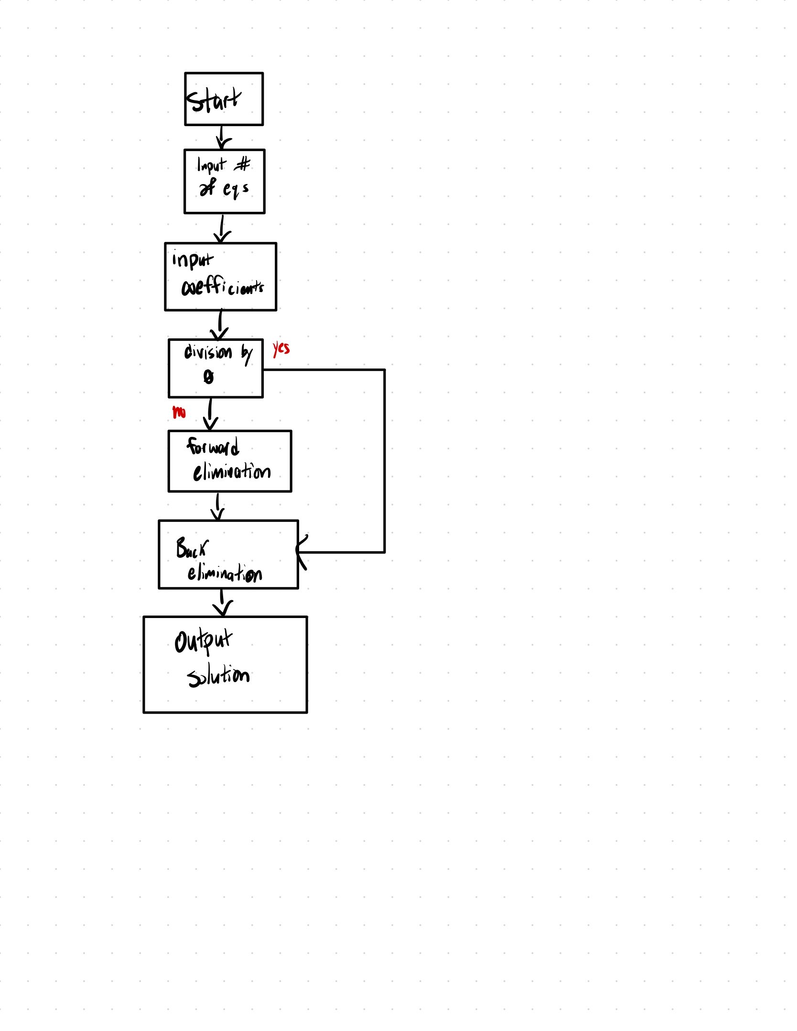
C. The code listing.

#include <iostream>
#include <iomanip>
#include <vector>
#include <cmath>

using namespace std;

int main() {
int n;
cout << "Enter the number of equations: ";
cin >> n;

vector<vector<double>> A(n, vector<double>(n + 1));
vector<double> x(n);

cout << "Enter the augmented matrix (each row should have " << n + 1 << " values):\n";
for (int i = 0; i < n; i++) {
cout << "Row " << i + 1 << ": ";
for (int j = 0; j <= n; j++) {
cin >> A[i][j];
}
}

// forward elimination
for (int i = 0; i < n - 1; i++) {
if (A[i][i] == 0.0) {
cout << "Division by zero detected during forward elimination.\n";
return 1;
}
for (int j = i + 1; j < n; j++) {
double ratio = A[j][i] / A[i][i];
for (int k = i; k <= n; k++) {
A[j][k] -= ratio * A[i][k];
}
}
}

// back substitution
for (int i = n - 1; i >= 0; i--) {
x[i] = A[i][n];
for (int j = i + 1; j < n; j++) {
x[i] -= A[i][j] * x[j];
}
if (A[i][i] == 0.0) {
cout << "Division by zero detected during back substitution.\n";
return 1;
}
x[i] /= A[i][i];
}

cout << "\nSolution:\n";
for (int i = 0; i < n; i++) {
cout << "x" << i + 1 << " = " << fixed << setprecision(4) << x[i] << endl;
}

system("pause");
return 0;
}

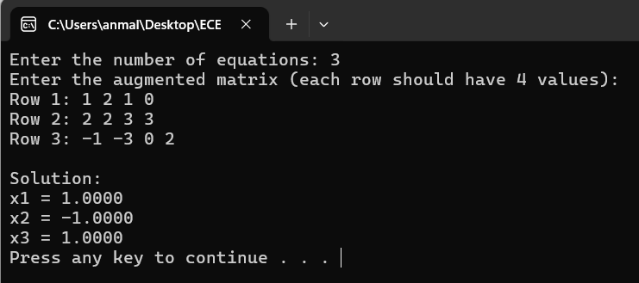
D. Screenshots demonstrating the operation of the program using the sets of 3, 4 and 5 equations that are shown above.
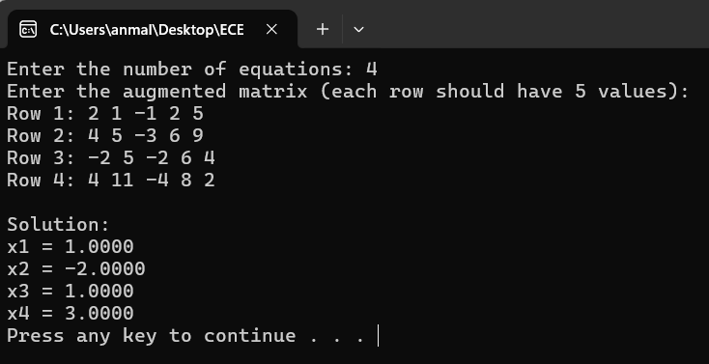
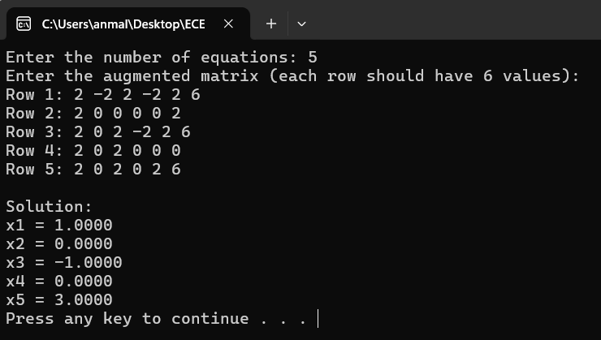
Submit a PDF document on Blackboard.

